Michael Chizy, Chairman  John L. Hebert, Vice Chairman  Richard Hersom, Clerk  Ryan Fattman  Kevin Geraghty  James A. Smith, Town Administrator | 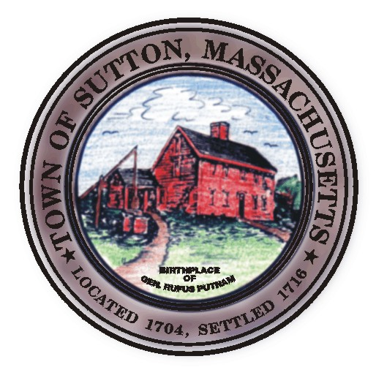 | Sutton Town Hall  4 Uxbridge Road  Sutton, Massachusetts 01590  (508) 865-8727  Fax: (508) 865-8721
Town Of Sutton
Board Of Selectmen

Meeting Agenda

7:00 p.m. – Tuesday, July 1st, 2008

Sutton Town Hall, Selectmen’s Meeting Room

- Call to Order, Pledge of Allegiance at 7:00 p.m.

- Public Forum: Limited to 5 minutes per topic. Discussion or comments about town employees or agency members shall be avoided so as not to violate individual’s rights.

- Minutes
  - Board of Selectman minutes from 06/17/08

IV. Sponsored Agenda and Action Items
2. Re appointments to Boards
3. Amendment to Building Dept. Fee increases
Electrical, Plumbing and Gas fee changes
4. Fire Dept fee changes
5. Request from Wilkinsonville Water District regarding water mains under public bridle path

V. Town Administrator Update
VI. Announcements
VII. Selectman’s Roundtable: Correspondence and Business Topics

Adjournment

